|  |  |  |  |  |  |  |  |  |  |  |  |  |  |
| --- | --- | --- | --- | --- | --- | --- | --- | --- | --- | --- | --- | --- | --- |
| **'Have Your Say’**  **Aspbury Planning Ltd is preparing an Outline Planning Application for a residential development for up to 52 dwellings and a parking alleviation scheme, to be submitted to Mansfield District Council on behalf of Nottinghamshire County Council (NCC) on land at ‘the former Sherwood Hall School Playing Fields’.**  We would welcome your comments to help shape the proposals to deliver housing that is needed in the area. | | |  |  | |  | | --- | | Aspbury Planning Ltd  A picture containing text  Description automatically generated 20 Park Lane Business Centre  Park Lane  Basford  Nottingham  NG6 0DW | |  | | | | A picture containing text  Description automatically generated  Website: [www.aspburyplanning.co.uk](http://www.aspburyplanning.co.uk)  Telephone: 0115 8528050 |  | Proposed  Residential Development    **Stuart Avenue, Mansfield, Nottingham**  Nottinghamshire County Council invites you to submit written comments for consideration by the project team to shape the development of the site.  Comments can be submitted via the webpage: [**www.aspburyplanning.co.uk**](http://www.aspburyplanning.co.uk)**/public-consultations/**  or by sending an email to:  [**office@aspburyplanning.co.uk**](mailto:office@aspburyplanning.co.uk)  (quoting "Stuart Avenue" in the subject line).  Please note the deadline for comments is  **Wednesday 5th June 2024.** | |
|  |  | **The Site**  Located east of Mansfield town is the Site known as ‘the former Sherwood Hall School Playing Fields’. Following the demolition of the fire-damaged school, Abbey Primary School was built leaving land to the south as surplus.  The Site is bounded by existing residential properties along Stuart Avenue to the north-east and Abbey Primary School and its associated playing fields to the west. | | |  | **The Application**  This is an opportunity for the residents of Mansfield to have your say on a ***proposed*** Planning Application ***before*** it is formally submitted to Mansfield District Council.  The Masterplan above is indicative at this stage and has been devised following technical investigations of the Site (transport, ecology, archaeology and drainage).  The design rationale for the Masterplan has been heavily influenced to respect the existing properties around the Site, providing public connectivity to the school and surrounding area.  The Application Site will be redeveloped to provide market and affordable housing and public accessible open space. Local Plan  process which is a separate matter. |  | | | |

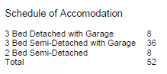

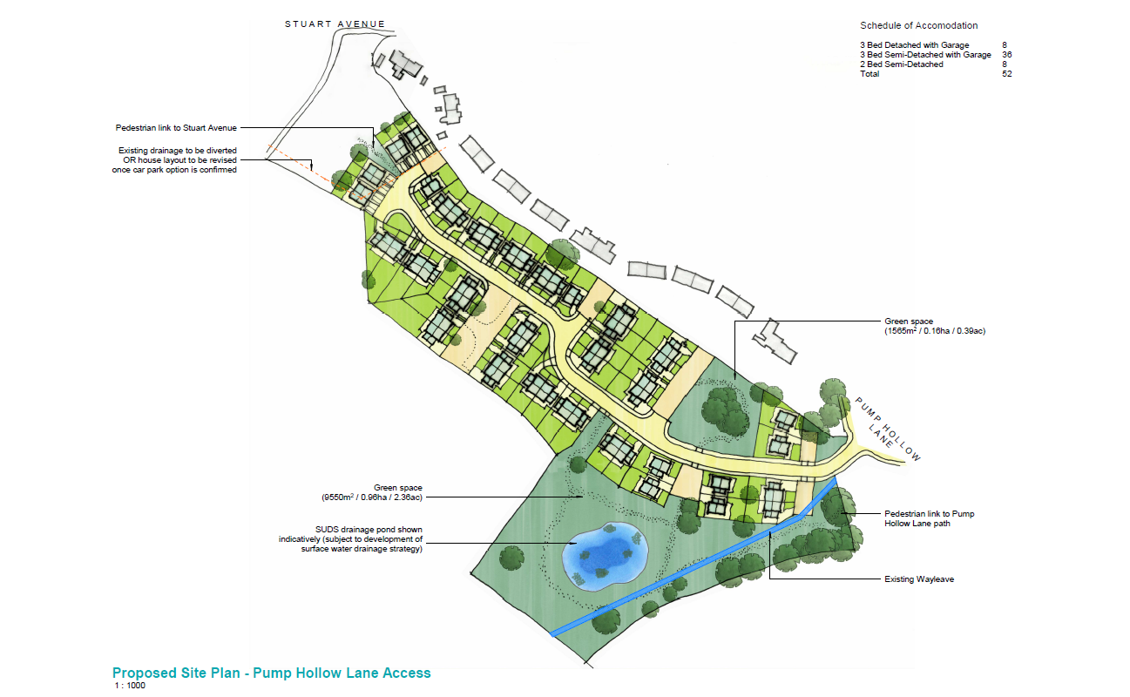

Site retained for parking alleviation ––––

Possible schedule of Accommodation

3 Bed Detached with Garage 8 3 Bed Semi-Detached with Garage 36 2 Bed Semi-Detached 8 Total 52

Pedestrian link to Stuart Avenue

Connect to existing drainage

Green public space (9550m2 / 0.96hs / 2.36ac)

SUDS drainage pond shown indicatively (subject to development of surface water drainage strategy

Green public space (1565m2 / 0.16ha / 0.39ac)

Pedestrian link to Pump Hollow Lane

Existing Wayleave

The Application will be submitted in ‘Outline’ seeking approval of the design of the new vehicular junction to the Site from Pump Hollow Lane. Details relating to the house types, design and layout will be reserved for separate, later approval.

To the north of the Site, an area is to be retained for a parking alleviation scheme that will be submitted as a separate Application. You will note that this proposal seeks to safeguard land that could be utilised to relieve current school drop off/collection parking issues and this consultation seeks your views on both the proposals for residential use and parking alleviation.